CHMG-141.02: General & Analytical Chemistry I
Recitation W1
With Dr. Bailey
Name: ______________________

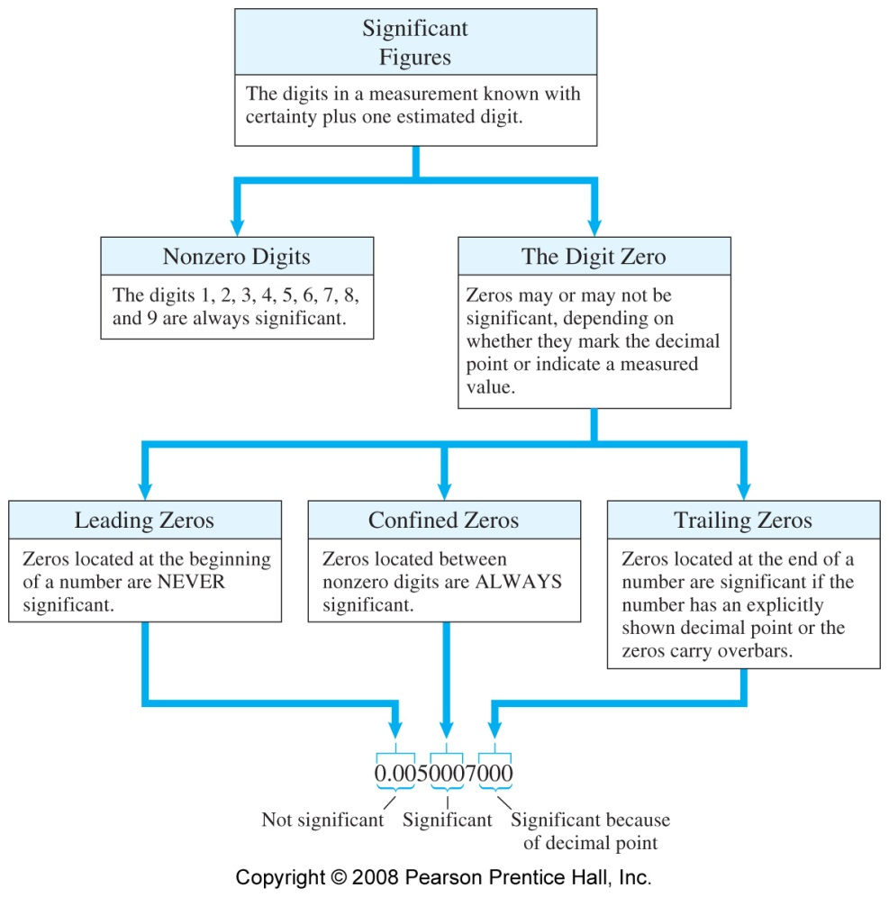

Problem 1.1: Indicate the number of significant figures in the following numbers:
- 0.00678
- 37.020
- 4.790x10⁶
- 105000

Problem 1.2: Write the following numbers using scientific notation. Be sure to include the correct number of significant figures in your answer.
- 0.0076
- 0.0250
- 1,210,500

Problem #2: Perform the following conversions and give your result in proper scientific notation with the appropriate number of significant figures.

- 10.5 mL to L

- 7.86 mm to m

- .0056 kg to dg

- 125.0 μs to Ms

- 4.58 cm to pm

Significant Figures in Calculations:
- Multiplication and Division: For multiplication and division, the number of significant figures in the answer should not be greater than the number of significant figures in the least precise measurement.
- Addition & Subtraction: Values must be converted to common units before adding or subtracting (that includes powers of ten). For addition and subtraction, the answer should have the same number of decimal places as the quantity with the fewest number of decimal places
- In multi-step calculations retain all figures in your calculator until the end, then use order of operations to determine the significant figures for the result.
4) Conversion factors always have less uncertainty than data.

Problem #3: Perform the following calculations and express your results using scientific notation with the appropriate number of significant figures. Pay attention for units!

a. 13.57 g + 7.062 g + 205.064 g.

b. 415. 098 g – 7.94 g.

c. 18.65 g ÷ 72.3 mL. Will this object float or sink in water?

d. 13.57 cm × 7.6 cm.

Problem #4: Perform each of the following temperature conversions. Pay attention for Sig Figs!

- 32 ºF to ºC ºC = 5/9 (ºF -32)

- 27 ºC to ºF ºF = 9/5 ºC + 32

- -27 ºC to K K = ºC + 273.15
Problem #5: Find the total time in minutes for a class that lasted 2.76 hours, 353 minutes and 45,980 seconds.

Problem #6: In 1989 the Exxon Valdez ran aground and spilled 240,000 barrels of crude oil off the coast of Alaska, leaving a 0.5 mm thick layer of oil covering the waters of Prince William Sound.
Using the conversion factors given below, determine the area of the oil slick in square miles.
Hint: Consider the spilled oil as a cylinder:
- Volume = Area x thickness, so
- Area = Volume/thickness
- Work with conversions to get proper units
- Round off the final answer correctly: one sig. fig. comes from the thickness 0.5mm
- 1 barrel = 42 gallons

